Use this procedure only when the DGS FTP is not available.
- Open your web browser
- Go to the link previously sent
- Click on Download
- Unzip the file
  - Password: OticonMedicalCI

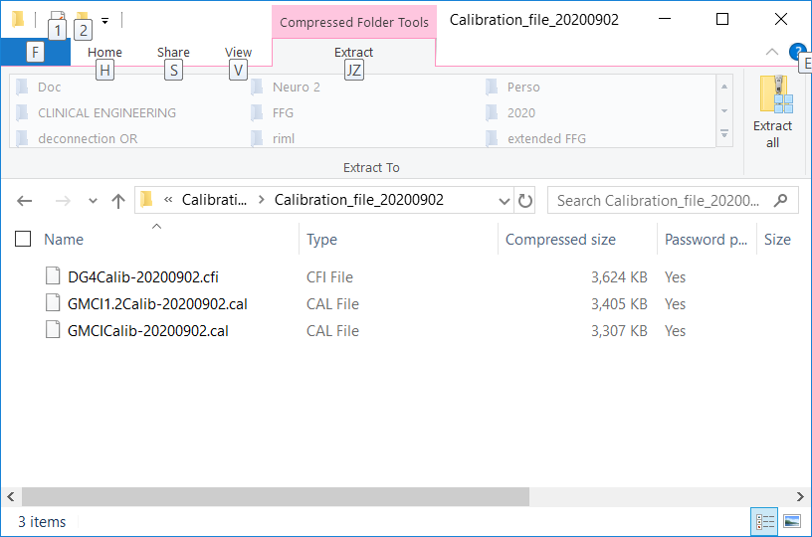
Calibration file for GMCI 5 (1.6)
Calibration file for GMCI 1.2
Calibration file for Digimap

- Copy the calibration file specific to your version from your download location and paste it to the PC desktop
- Open GMCI
- Click on File, then Calibration file update
GMCI window

- From your Desktop select the calibration file and click on “open”

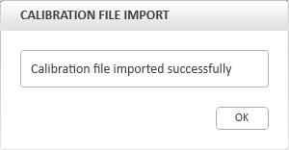

Your calibration file is now updated.

You can verify the calibration date update from Help, About, and compare the date with the calibration file name.
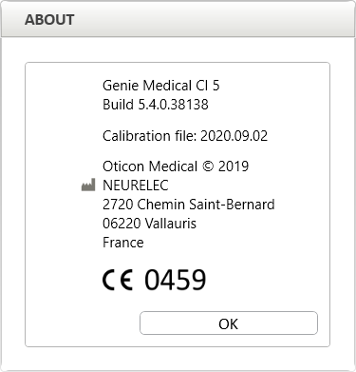

Reminder: if you are using a remote database, you need to update all local PCs.

What to do in case of error?

You can face the following message

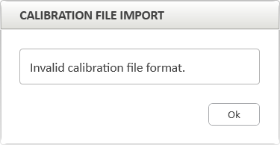
Error message

- Make sure you have not selected the calibration file for GMCI R.1.2, in this case, go back to step 5 and download the correct calibration file
- Make sure you have not imported the calibration file from shared folder, in this case go back to step 5
- If you did not manage to resolve the problem with steps 9 and 10, open the fitting guide from Help, fitting guide, close the fitting guide and go back on step 5.

- If you did not manage to resolve the problem with previous steps, install the certificates (see next chapter) intermediate.cer and neurelec.cer see below and go back to step 6

Note: If the PC has multiple user sessions, which can be used to upgrade the calibration file then you need to repeat those steps for each user session.

You can face the following message

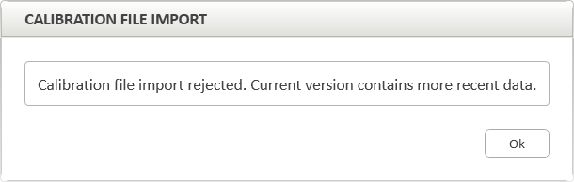
GMCI message

- The calibration file you try to upload is already installed or older than the one installed

How to install the certificates?

- Unzip the folder certificates.zip
- Double click on the first certificate
- Click on Install Certificate…

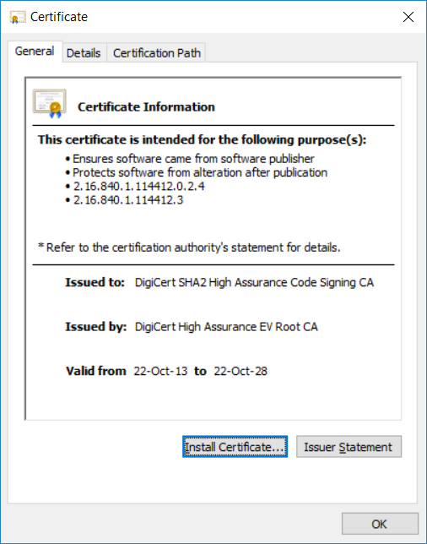
Certificates installation- step 1

- Select Current User and click on Next

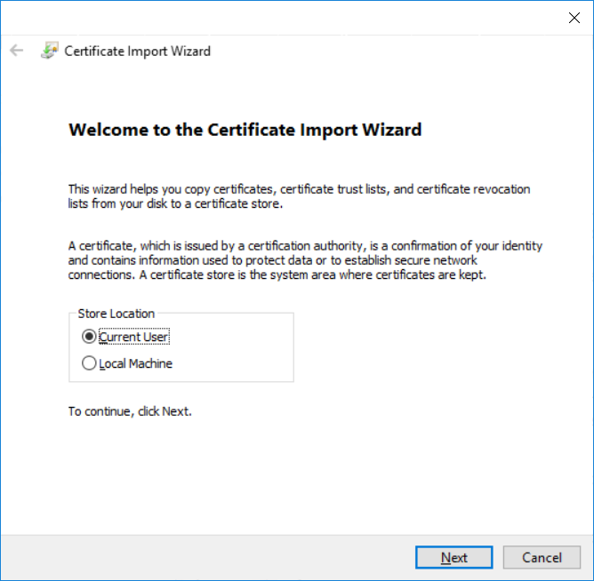
Certificates installation – step 2

- Select “Automatically select the certificate store based on the type of certificate “and click on Next

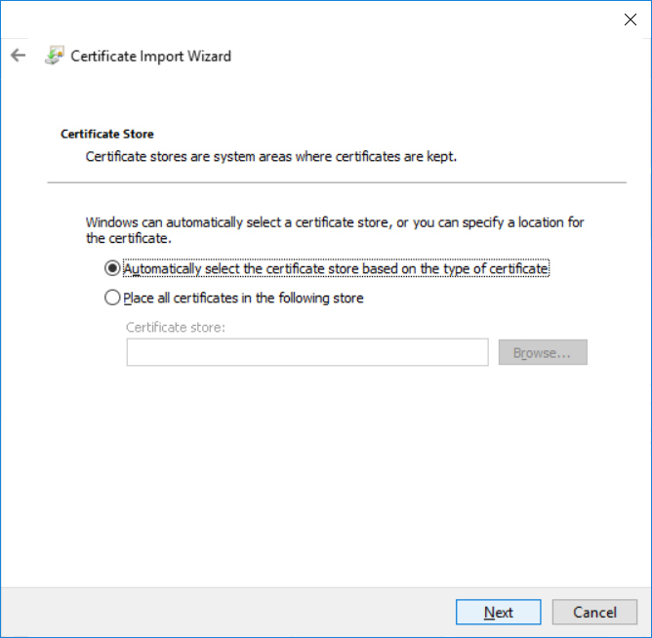
Certificates installation – step 3

- Select “Certificate Store Selected “and click on Finish

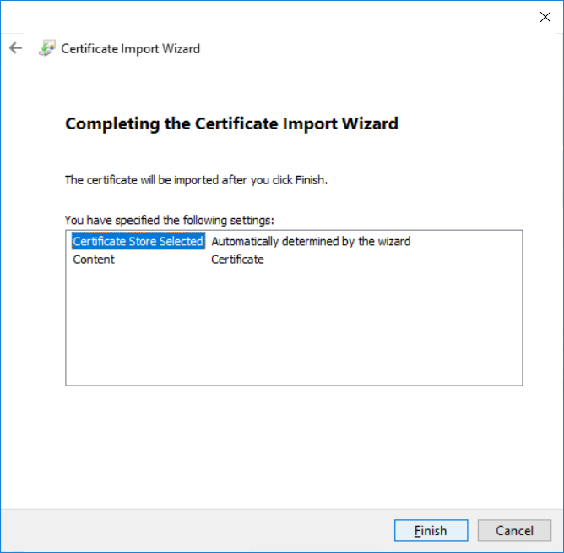
Certificates installation – step 4

- Restart the same steps with the second certificate

